Table of Contents
- Introduction
  - Purpose
  - Scope
  - Definitions, Acronyms, and Abbreviations
  - Overview
- Overall Description
  - Product Perspective
  - Product Features
  - User Classes and Characteristics
  - Operating Environment
  - Design and Implementation Constraints
  - Assumptions and Dependencies
- System Features
  - User Registration and Authentication
  - Bus Search and Booking
  - Payment Processing
  - Ticket Management
  - Admin Dashboard
- External Interface Requirements
  - User Interfaces
  - Hardware Interfaces
  - Software Interfaces
  - Communications Interfaces
- System Requirements
  - Functional Requirements
  - Performance Requirements
  - Security Requirements
  - Software Quality Attributes
- Other Nonfunctional Requirements
  - Reliability
  - Availability
  - Scalability
  - Maintainability
- Appendices
  - Glossary
  - Analysis Models
  - Issues List

1. Introduction

1.1 Purpose
The purpose of this document is to provide a detailed description of the requirements for the Bus Reservation System. It will outline the system's functionality, constraints, and interactions with external systems.

1.2 Scope
This SRS document covers the functional and non-functional requirements for the Bus Reservation System, which allows users to book bus tickets online, manage bookings, and for administrators to manage the system.

1.3 Abbreviations
- SRS: Software Requirements Specification
- UI: User Interface
- API: Application Programming Interface
- DBMS: Database Management System

1.4 Overview
This document is organized into sections detailing the system's overall description, specific features, external interface requirements, system requirements, and nonfunctional requirements.

2. Overall Description

2.1 Product Perspective
The Bus Reservation System is a standalone application designed to replace the current manual ticket booking process with an automated online system. It will interact with external payment gateways and SMS/email services for notifications.

2.2 Product Features
- User registration and login
- Search for buses based on criteria (date, time, source, destination)
- Online ticket booking and cancellation
- Payment integration
- Admin dashboard for managing buses, routes, and bookings
- Notifications via email/SMS

2.3 User Classes and Characteristics
- Passengers: Individuals looking to book bus tickets.
- Administrators: Manage the system, buses, routes, and monitor bookings.

2.4 Operating Environment
- Web-based application accessible via modern web browsers (Chrome, Firefox, Safari)
- Backend server running on a web server (e.g., Apache, Nginx)
- Database server (e.g., MySQL, PostgreSQL)

2.5 Design and Implementation Constraints
- Must comply with data protection regulations
- Limited to the resources available (budget, time)

2.6 Assumptions and Dependencies
- Users have internet access
- Payment gateways are operational and have API access

3. System Features

3.1 User Registration and Authentication

3.1.1 Description and Priority
Users must register and authenticate to book tickets. This is a high-priority feature.

3.1.2 Stimulus/Response Sequences
- User registers with personal details.
- System sends a confirmation email.
- User logs in with credentials.

3.1.3 Functional Requirements
- The system shall allow users to register using their email and password.
- The system shall send a confirmation email upon registration.
- The system shall authenticate users during login.

3.2 Bus Search and Booking

3.2.1 Description and Priority
Users can search for available buses and book tickets. This is the core feature of the system.

3.2.2 Stimulus/Response Sequences
- User searches for buses using criteria.
- System displays available buses.
- User selects a bus and books a ticket.

3.2.3 Functional Requirements
- The system shall allow users to search for buses by date, time, source, and destination.
- The system shall display available seats and ticket prices.
- The system shall allow users to book tickets.

3.3 Payment Processing

3.3.1 Description and Priority
Handle payment transactions securely. This is a high-priority feature.

3.3.2 Stimulus/Response Sequences
- User proceeds to payment after booking.
- System processes payment via payment gateway.
- System confirms booking upon successful payment.

3.3.3 Functional Requirements
- The system shall integrate with payment gateways for processing payments.
- The system shall confirm bookings only after successful payment.
- The system shall send payment confirmation via email/SMS.

3.4 Ticket Management

3.4.1 Description and Priority
Users can view, print, and cancel tickets. This is a high-priority feature.

3.4.2 Stimulus/Response Sequences
- User views booked tickets.
- User prints or cancels a ticket.

3.4.3 Functional Requirements
- The system shall allow users to view their booked tickets.
- The system shall allow users to print their tickets.
- The system shall allow users to cancel their tickets and process refunds as per policy.

3.5 Admin Dashboard

3.5.1 Description and Priority
Administrators manage buses, routes, and monitor bookings. This is a medium-priority feature.

3.5.2 Stimulus/Response Sequences
- Admin logs into the dashboard.
- Admin manages bus and route information.
- Admin monitors bookings and generates reports.

3.5.3 Functional Requirements
- The system shall provide an admin dashboard with login.
- The system shall allow admins to add, update, and delete buses and routes.
- The system shall provide booking monitoring and reporting features.

4. External Interface Requirements

4.1 User Interfaces
- Web-based UI for users and administrators.
- Responsive design for mobile and desktop use.

4.2 Hardware Interfaces
- Server hosting requirements.
- User devices (PCs, tablets, smartphones).

4.3 Software Interfaces
- APIs for payment gateway integration.
- Email/SMS service integration.

4.4 Communications Interfaces
- HTTPS for secure communication.

5. System Requirements

5.1 Functional Requirements
- Refer to section 3 for detailed functional requirements.

5.2 Performance Requirements
- The system should handle up to 1000 concurrent users.
- The response time for search and booking operations should be less than 3 seconds.

5.3 Security Requirements
- User data must be encrypted.
- Secure authentication and authorization mechanisms.

5.4 Software Quality Attributes
- Usability: The system should be easy to use.
- Reliability: The system should be available 99.9% of the time.
- Maintainability: The system should be easy to maintain and update.

6. Other Nonfunctional Requirements

6.1 Reliability
- The system should have a high uptime with minimal downtime.

6.2 Availability
- The system should be available 24/7, with maintenance windows announced in advance.

6.3 Scalability
- The system should be scalable to accommodate growing numbers of users and bookings.

6.4 Maintainability
- The system should be modular and use standard coding practices to facilitate maintenance.

7. Appendices

7.1 Glossary
- User: A person who books tickets using the system.
- Admin: A person who manages the system.
- Ticket: A confirmation for a reserved seat on a bus.

7.2 Analysis Models
- UML diagrams of the system architecture and workflows.

7.3 Issues List
- List of known issues and their statuses.
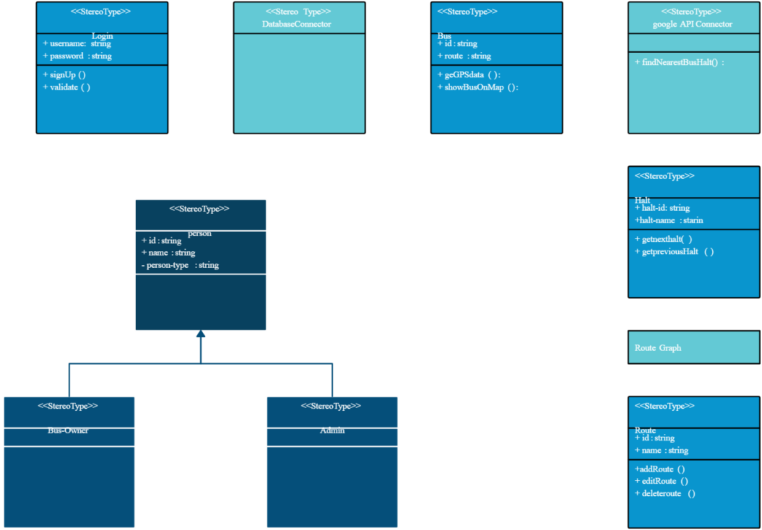
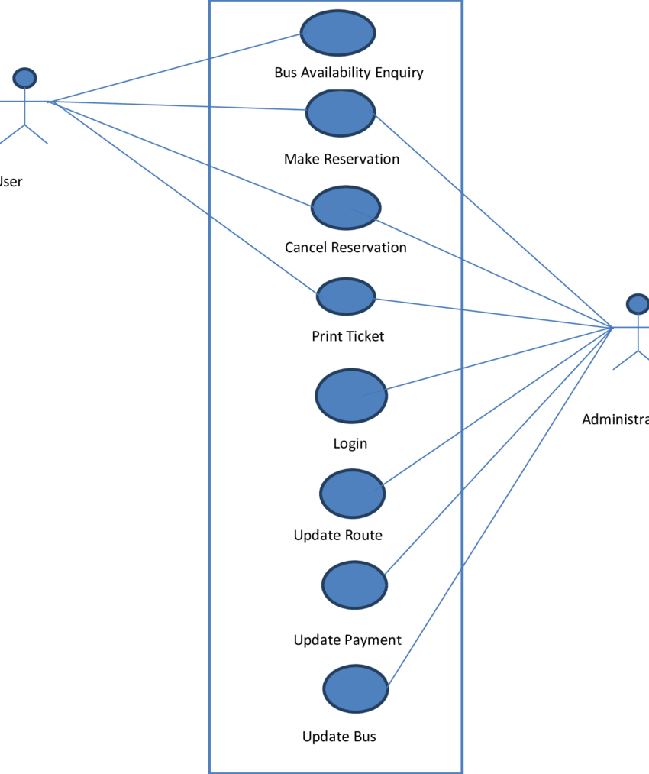USE CASE 1.

Class diagram

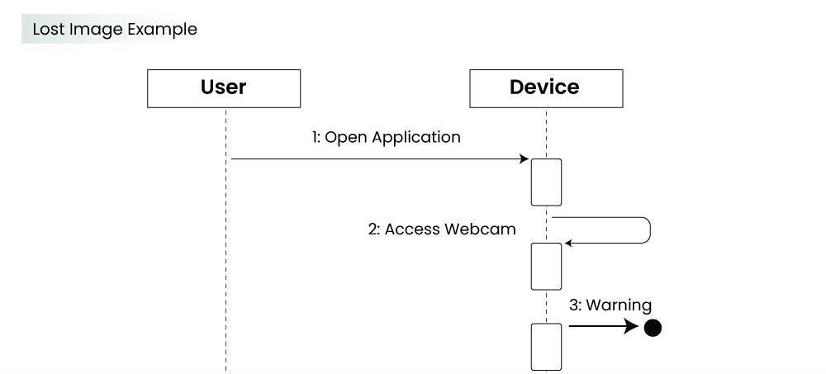
Sequence diagram

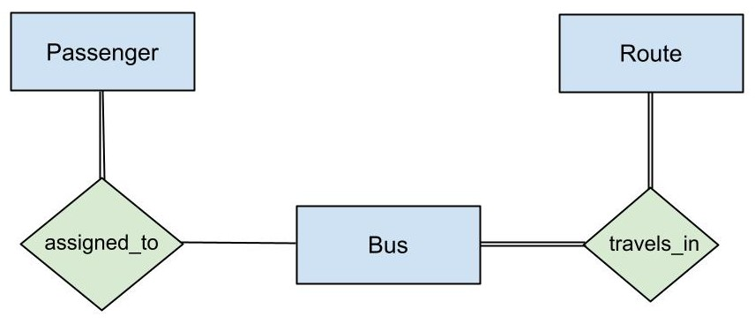
Collaboration Diagram

State diagram
